Мюжгян Адем Томар, 4 курс, спец. Приложна математика, ф. Номер: 1101391001

ЗАД. 1 1-Да се запишат данните от stpsamp.sale в work.mysales. 2- Да се отпечтат данните от work.mysales. 3- Да се сортират данните и 4- да се отпечатат сортирните данни.5- Да се изведе информация за таблиците (брой колони, брой изследвания, типа на колините). 6- Да се групират данните по региони с променлива количество. 7- Да се извади средната цена на продадените продукти по продукти А100, А200, А300.
- Записваме данните в work.mysales.

data work.mysales;
set stpsamp.stpsale;
run;

Данните вече са записани в work.mysales.
- Отпечатваме данните от work.mysales и даваме име на таблицата Results of my sales.

title "Results of my sales"; (Даваме Името на таблицата)
proc print data=work.mysales; (отпечатваме данните от work.mysale)
run;

Results of my sales
Obs | region | citysize | pop | product | saletype | quantity | amount
1 | NC | S | 25000 | A100 | R | 150 | 3750
2 | NE | S | 37000 | A100 | R | 200 | 5000
3 | SO | S | 48000 | A100 | R | 410 | 10250
4 | WE | S | 32000 | A100 | R | 180 | 4500
5 | NC | M | 125000 | A100 | R | 350 | 8750
6 | NE | M | 237000 | A100 | R | 600 | 15000
7 | SO | M | 348000 | A100 | R | 710 | 17750
8 | WE | M | 432000 | A100 | R | 780 | 19500
9 | NE | L | 837000 | A100 | R | 800 | 20000
10 | SO | L | 748000 | A100 | R | 760 | 19000
11 | WE | L | 932000 | A100 | R | 880 | 22000
12 | NC | S | 25000 | A100 | W | 150 | 3000
13 | NE | S | 37000 | A100 | W | 200 | 4000
14 | WE | S | 32000 | A100 | W | 180 | 3600
15 | NC | M | 125000 | A100 | W | 350 | 7000
16 | NE | M | 237000 | A100 | W | 600 | 12000
17 | SO | M | 348000 | A100 | W | 710 | 14200
18 | WE | M | 432000 | A100 | W | 780 | 15600
19 | NC | L | 625000 | A100 | W | 750 | 15000
20 | NE | L | 837000 | A100 | W | 800 | 16000
21 | SO | L | 748000 | A100 | W | 760 | 15200
22 | WE | L | 932000 | A100 | W | 880 | 17600
23 | NC | S | 25000 | A200 | R | 165 | 4125
24 | NE | S | 37000 | A200 | R | 215 | 5375
25 | SO | S | 48000 | A200 | R | 425 | 10425
26 | WE | S | 32000 | A200 | R | 195 | 4875
27 | NC | M | 125000 | A200 | R | 365 | 9125
28 | NE | M | 237000 | A200 | R | 615 | 15375
29 | SO | M | 348000 | A200 | R | 725 | 19125
30 | WE | M | 432000 | A200 | R | 795 | 19875
31 | NE | L | 837000 | A200 | R | 815 | 20375
32 | SO | L | 748000 | A200 | R | 775 | 19375
33 | WE | L | 932000 | A200 | R | 895 | 22375
34 | NC | S | 25000 | A200 | W | 165 | 3300
35 | NE | S | 37000 | A200 | W | 215 | 4300
36 | WE | S | 32000 | A200 | W | 195 | 3900
37 | NC | M | 125000 | A200 | W | 365 | 7300
38 | NE | M | 237000 | A200 | W | 615 | 12300
39 | SO | M | 348000 | A200 | W | 725 | 14500
40 | WE | M | 432000 | A200 | W | 795 | 15900
41 | NC | L | 625000 | A200 | W | 765 | 15300
42 | NE | L | 837000 | A200 | W | 815 | 16300
43 | SO | L | 748000 | A200 | W | 775 | 15500
44 | WE | L | 932000 | A200 | W | 895 | 17900
45 | NC | S | 25000 | A300 | R | 157 | 3925
46 | NE | S | 37000 | A300 | R | 208 | 5200
47 | SO | S | 48000 | A300 | R | 419 | 10475
48 | WE | S | 32000 | A300 | R | 186 | 4650
49 | NC | M | 125000 | A300 | R | 351 | 8725
50 | NE | M | 237000 | A300 | R | 610 | 15250
51 | SO | M | 348000 | A300 | R | 714 | 17850
52 | WE | M | 432000 | A300 | R | 785 | 19625
53 | NE | L | 837000 | A300 | R | 806 | 20150
54 | SO | L | 748000 | A300 | R | 768 | 19200
55 | WE | L | 932000 | A300 | R | 880 | 22000
56 | NC | S | 25000 | A300 | W | 157 | 3140
57 | NE | S | 37000 | A300 | W | 208 | 4160
58 | WE | S | 32000 | A300 | W | 186 | 3720
59 | NC | M | 125000 | A300 | W | 351 | 7020
60 | NE | M | 237000 | A300 | W | 610 | 12200
61 | SO | M | 348000 | A300 | W | 714 | 14280
62 | WE | M | 432000 | A300 | W | 785 | 15700
63 | NC | L | 625000 | A300 | W | 757 | 15140
64 | NE | L | 837000 | A300 | W | 806 | 16120
65 | SO | L | 748000 | A300 | W | 768 | 15360
66 | WE | L | 932000 | A300 | W | 880 | 17600

- Сортираме данните по продукт и количество.

proc sort data=work.mysales;
by product quantity;
run;

- Отпечатваме сортираните данни и даваме име на таблицата Sorted Results of my sales.
proc print data=work.mysales;
run;

Sorted results of my sales
Obs | region | citysize | pop | product | saletype | quantity | amount
1 | NC | S | 25000 | A100 | R | 150 | 3750
2 | NC | S | 25000 | A100 | W | 150 | 3000
3 | WE | S | 32000 | A100 | R | 180 | 4500
4 | WE | S | 32000 | A100 | W | 180 | 3600
5 | NE | S | 37000 | A100 | R | 200 | 5000
6 | NE | S | 37000 | A100 | W | 200 | 4000
7 | NC | M | 125000 | A100 | R | 350 | 8750
8 | NC | M | 125000 | A100 | W | 350 | 7000
9 | SO | S | 48000 | A100 | R | 410 | 10250
10 | NE | M | 237000 | A100 | R | 600 | 15000
11 | NE | M | 237000 | A100 | W | 600 | 12000
12 | SO | M | 348000 | A100 | R | 710 | 17750
13 | SO | M | 348000 | A100 | W | 710 | 14200
14 | NC | L | 625000 | A100 | W | 750 | 15000
15 | SO | L | 748000 | A100 | R | 760 | 19000
16 | SO | L | 748000 | A100 | W | 760 | 15200
17 | WE | M | 432000 | A100 | R | 780 | 19500
18 | WE | M | 432000 | A100 | W | 780 | 15600
19 | NE | L | 837000 | A100 | R | 800 | 20000
20 | NE | L | 837000 | A100 | W | 800 | 16000
21 | WE | L | 932000 | A100 | R | 880 | 22000
22 | WE | L | 932000 | A100 | W | 880 | 17600
23 | NC | S | 25000 | A200 | R | 165 | 4125
24 | NC | S | 25000 | A200 | W | 165 | 3300
25 | WE | S | 32000 | A200 | R | 195 | 4875
26 | WE | S | 32000 | A200 | W | 195 | 3900
27 | NE | S | 37000 | A200 | R | 215 | 5375
28 | NE | S | 37000 | A200 | W | 215 | 4300
29 | NC | M | 125000 | A200 | R | 365 | 9125
30 | NC | M | 125000 | A200 | W | 365 | 7300
31 | SO | S | 48000 | A200 | R | 425 | 10425
32 | NE | M | 237000 | A200 | R | 615 | 15375
33 | NE | M | 237000 | A200 | W | 615 | 12300
34 | SO | M | 348000 | A200 | R | 725 | 19125
35 | SO | M | 348000 | A200 | W | 725 | 14500
36 | NC | L | 625000 | A200 | W | 765 | 15300
37 | SO | L | 748000 | A200 | R | 775 | 19375
38 | SO | L | 748000 | A200 | W | 775 | 15500
39 | WE | M | 432000 | A200 | R | 795 | 19875
40 | WE | M | 432000 | A200 | W | 795 | 15900
41 | NE | L | 837000 | A200 | R | 815 | 20375
42 | NE | L | 837000 | A200 | W | 815 | 16300
43 | WE | L | 932000 | A200 | R | 895 | 22375
44 | WE | L | 932000 | A200 | W | 895 | 17900
45 | NC | S | 25000 | A300 | R | 157 | 3925
46 | NC | S | 25000 | A300 | W | 157 | 3140
47 | WE | S | 32000 | A300 | R | 186 | 4650
48 | WE | S | 32000 | A300 | W | 186 | 3720
49 | NE | S | 37000 | A300 | R | 208 | 5200
50 | NE | S | 37000 | A300 | W | 208 | 4160
51 | NC | M | 125000 | A300 | R | 351 | 8725
52 | NC | M | 125000 | A300 | W | 351 | 7020
53 | SO | S | 48000 | A300 | R | 419 | 10475
54 | NE | M | 237000 | A300 | R | 610 | 15250
55 | NE | M | 237000 | A300 | W | 610 | 12200
56 | SO | M | 348000 | A300 | R | 714 | 17850
57 | SO | M | 348000 | A300 | W | 714 | 14280
58 | NC | L | 625000 | A300 | W | 757 | 15140
59 | SO | L | 748000 | A300 | R | 768 | 19200
60 | SO | L | 748000 | A300 | W | 768 | 15360
61 | WE | M | 432000 | A300 | R | 785 | 19625
62 | WE | M | 432000 | A300 | W | 785 | 15700
63 | NE | L | 837000 | A300 | R | 806 | 20150
64 | NE | L | 837000 | A300 | W | 806 | 16120
65 | WE | L | 932000 | A300 | R | 880 | 22000
66 | WE | L | 932000 | A300 | W | 880 | 17600

- proc contents data=work.mysales;
run;

резултатът, който излиза показва следното:
The CONTENTS Procedure
Data Set Name | WORK.MYSALES | Observations | 66
Member Type | DATA | Variables | 7
Engine | V9 | Indexes | 0
Created | 08.03.2015 13:37:46 | Observation Length | 56
Last Modified | 08.03.2015 13:37:46 | Deleted Observations | 0
Protection |  | Compressed | NO
Data Set Type |  | Sorted | YES
Label
Data Representation | SOLARIS_X86_64, LINUX_X86_64, ALPHA_TRU64, LINUX_IA64
Encoding | utf-8 Unicode (UTF-8)

Виждат се броя на наблюденията, броят на промелнивите (колонките), кога е създадена таблицата.

Engine/Host Dependent Information
Data Set Page Size 131072
Number of Data Set Pages 1
First Data Page 1
Max Obs per Page 2334
Obs in First Data Page 66
Number of Data Set Repairs 0
Filename /saswork/SAS_work22CF00006381_odaws02-ie.oda.sas.com/SAS_workA7FA00006381_odaws02-ie.oda.sas.com/mysales.sas7bdat
Release Created 9.0401M2
Host Created Linux
Inode Number 26214421
Access Permission rw-rw-r--
Owner Name mija92
File Size (bytes) 262144

Тук се вижда рзмер на файла, от кого е използван името му.

Alphabetic List of Variables and Attributes
# | Variable | Type | Len
7 | amount | Num | 8
2 | citysize | Char | 8
3 | pop | Num | 8
4 | product | Char | 8
6 | quantity | Num | 8
1 | region | Char | 8
5 | saletype | Char | 8

Изкарва броя на колонките, имената им, типа им и дължината на данните, които могат да се записват в тях, като ги подрежда по азбучен ред.

Sort Information
Sortedby product quantity
Validated YES
Character Set ASCII
Тъй като сортирахме данните излезна ни информация, че данните са сортирани по продукт и количество.

- proc tabulate data=work.mysales;
class region; /*Групиране по регион*/
var quantity; /*Променлива- количество*/
table region*quantity;
run;

Резултът е:

region
NC | NE | SO | WE
quantity | quantity | quantity | quantity
Sum | Sum | Sum | Sum
5348.00 | 9738.00 | 10158.00 | 11152.00

Вижда се колко е сумата от количеството по региони.

- proc tabulate data=work.mysales;
class product; /*въвеждаме класът продукт, по който ще се групира*/
var amount; /*въвеждаме променливата, на която ще търсим средната стойност*/
table product*amount, mean; /* c mean ще намерим средната стойност на цената на продадените продукти*/
run;

Резултатът е:

 |  | Mean
product |  | 12213.64
A100 | amount
A200 | amount | 12587.50
A300 | amount | 12340.45

ЗАД. 2 1- Да се запишат данните от SASHELP.SHOES в work.shoes и да се принтират данните. 2- Да се изкара средното на продадените стоки и наличноста, с която разполагат. 3- Да се извади медианата, средното, минималната стойност, максималната стойност на продадените стоки и наличността по продукти. 4- Да се изведе честотна таблица на данните за продуктите. 5- Оформете текст на отпечатване на заглавието стил- ариел, дебелина 1.0, цвят зелен. 6- Начертайте вертикална хистограма на таблица shoes за количествената променлива продажби. 7- Начертайте хоризонтапна хистограма в червено за качествената променлива продукт. 8- Начертайте кръгова диаграма за продукт в цвят син. 9- Начертайте кръгова 3D диаграма за продукт без дa задавате цвят. 10- Начертайте графика за продукт и продажби. 11- Свържете данните от предната графика с линия. 12- Променете отбелязването на точките по графикатат със звездичка.

- data shoes;
set sashelp.shoes;
run;

proc print data=work.shoes;
run;

резултатът е:

Obs | Region | Product | Subsidiary | Stores | Sales | Inventory | Returns
1 | Africa | Boot | Addis Ababa | 12 | $29,761 | $191,821 | $769
2 | Africa | Men's Casual | Addis Ababa | 4 | $67,242 | $118,036 | $2,284
3 | Africa | Men's Dress | Addis Ababa | 7 | $76,793 | $136,273 | $2,433
4 | Africa | Sandal | Addis Ababa | 10 | $62,819 | $204,284 | $1,861
5 | Africa | Slipper | Addis Ababa | 14 | $68,641 | $279,795 | $1,771
6 | Africa | Sport Shoe | Addis Ababa | 4 | $1,690 | $16,634 | $79
7 | Africa | Women's Casual | Addis Ababa | 2 | $51,541 | $98,641 | $940
8 | Africa | Women's Dress | Addis Ababa | 12 | $108,942 | $311,017 | $3,233
9 | Africa | Boot | Algiers | 21 | $21,297 | $73,737 | $710
10 | Africa | Men's Casual | Algiers | 4 | $63,206 | $100,982 | $2,221
11 | Africa | Men's Dress | Algiers | 13 | $123,743 | $428,575 | $3,621
12 | Africa | Sandal | Algiers | 25 | $29,198 | $84,447 | $1,530
13 | Africa | Slipper | Algiers | 17 | $64,891 | $248,198 | $1,823
14 | Africa | Sport Shoe | Algiers | 9 | $2,617 | $9,372 | $168
15 | Africa | Women's Dress | Algiers | 12 | $90,648 | $266,805 | $2,690
16 | Africa | Boot | Cairo | 20 | $4,846 | $18,965 | $229
17 | Africa | Men's Casual | Cairo | 25 | $360,209 | $1,063,251 | $9,424
18 | Africa | Men's Dress | Cairo | 5 | $4,051 | $45,962 | $97
19 | Africa | Sandal | Cairo | 9 | $10,532 | $50,430 | $598
20 | Africa | Slipper | Cairo | 9 | $13,732 | $54,117 | $1,216
21 | Africa | Sport Shoe | Cairo | 3 | $2,259 | $20,815 | $44
22 | Africa | Women's Casual | Cairo | 14 | $328,474 | $940,851 | $10,124
23 | Africa | Women's Dress | Cairo | 3 | $14,095 | $51,145 | $745
24 | Africa | Boot | Johannesburg | 14 | $8,365 | $33,011 | $483
25 | Africa | Sandal | Johannesburg | 13 | $17,337 | $63,003 | $809
26 | Africa | Slipper | Johannesburg | 12 | $39,452 | $130,025 | $1,565
27 | Africa | Sport Shoe | Johannesburg | 8 | $5,172 | $29,368 | $139
28 | Africa | Women's Dress | Johannesburg | 4 | $42,682 | $120,127 | $966
29 | Africa | Boot | Khartoum | 24 | $19,282 | $105,370 | $700
30 | Africa | Men's Casual | Khartoum | 1 | $9,244 | $16,230 | $478
31 | Africa | Men's Dress | Khartoum | 3 | $18,053 | $51,132 | $1,177
32 | Africa | Sandal | Khartoum | 18 | $26,427 | $81,825 | $1,281
33 | Africa | Slipper | Khartoum | 11 | $43,452 | $143,015 | $1,573
34 | Africa | Sport Shoe | Khartoum | 7 | $2,521 | $27,041 | $84
35 | Africa | Women's Casual | Khartoum | 1 | $19,582 | $30,727 | $384
36 | Africa | Women's Dress | Khartoum | 6 | $48,031 | $132,679 | $1,374
37 | Africa | Boot | Kinshasa | 16 | $13,921 | $70,736 | $553
38 | Africa | Men's Dress | Kinshasa | 5 | $57,691 | $95,663 | $1,699
39 | Africa | Sandal | Kinshasa | 10 | $16,662 | $104,438 | $611
40 | Africa | Slipper | Kinshasa | 11 | $52,807 | $183,937 | $1,440
41 | Africa | Sport Shoe | Kinshasa | 10 | $4,888 | $27,998 | $162
42 | Africa | Women's Casual | Kinshasa | 1 | $17,919 | $21,363 | $400
43 | Africa | Women's Dress | Kinshasa | 3 | $32,928 | $87,149 | $717
44 | Africa | Boot | Luanda | 8 | $6,081 | $51,572 | $325
45 | Africa | Men's Casual | Luanda | 3 | $62,893 | $149,864 | $1,701
46 | Africa | Men's Dress | Luanda | 2 | $29,582 | $67,247 | $705
47 | Africa | Sandal | Luanda | 9 | $11,145 | $19,900 | $657
48 | Africa | Slipper | Luanda | 5 | $19,146 | $97,060 | $701
49 | Africa | Sport Shoe | Luanda | 2 | $801 | $3,247 | $29
50 | Africa | Women's Dress | Luanda | 1 | $8,467 | $47,387 | $210
51 | Africa | Boot | Nairobi | 25 | $16,282 | $66,017 | $844
52 | Africa | Men's Dress | Nairobi | 1 | $8,587 | $20,877 | $363
53 | Africa | Sandal | Nairobi | 19 | $16,289 | $47,406 | $1,175
54 | Africa | Slipper | Nairobi | 12 | $34,955 | $87,438 | $1,320
55 | Africa | Sport Shoe | Nairobi | 10 | $2,202 | $11,328 | $174
56 | Africa | Women's Dress | Nairobi | 3 | $28,515 | $62,740 | $678
57 | Asia | Boot | Bangkok | 1 | $1,996 | $9,576 | $80
58 | Asia | Men's Dress | Bangkok | 1 | $3,033 | $20,831 | $52
59 | Asia | Sandal | Bangkok | 1 | $3,230 | $15,087 | $120
60 | Asia | Slipper | Bangkok | 1 | $3,019 | $16,075 | $127
61 | Asia | Women's Casual | Bangkok | 1 | $5,389 | $16,251 | $185
62 | Asia | Boot | Seoul | 17 | $60,712 | $160,589 | $1,296
63 | Asia | Men's Casual | Seoul | 1 | $11,754 | $2,176 | $833
64 | Asia | Men's Dress | Seoul | 7 | $116,333 | $251,803 | $2,443
65 | Asia | Sandal | Seoul | 3 | $4,978 | $21,483 | $105
66 | Asia | Slipper | Seoul | 21 | $149,013 | $469,007 | $2,941
67 | Asia | Sport Shoe | Seoul | 1 | $937 | $455 | $10
68 | Asia | Women's Casual | Seoul | 2 | $20,448 | $36,576 | $790
69 | Asia | Women's Dress | Seoul | 7 | $78,234 | $140,628 | $1,891
70 | Asia | Sport Shoe | Tokyo | 1 | $1,155 | $15,602 | $22
71 | Canada | Boot | Calgary | 8 | $17,720 | $63,280 | $472
72 | Canada | Men's Dress | Calgary | 1 | $12,775 | $39,663 | $353
73 | Canada | Sandal | Calgary | 7 | $2,886 | $15,838 | $147
74 | Canada | Slipper | Calgary | 2 | $5,676 | $48,061 | $253
75 | Canada | Sport Shoe | Calgary | 9 | $9,745 | $38,059 | $264
76 | Canada | Women's Dress | Calgary | 2 | $12,601 | $54,677 | $488
77 | Canada | Boot | Montreal | 25 | $40,213 | $240,132 | $1,472
78 | Canada | Men's Casual | Montreal | 3 | $53,929 | $187,155 | $2,241
79 | Canada | Men's Dress | Montreal | 11 | $112,009 | $355,170 | $3,713
80 | Canada | Sandal | Montreal | 7 | $3,002 | $18,382 | $122
81 | Canada | Slipper | Montreal | 24 | $135,305 | $500,053 | $3,395
82 | Canada | Sport Shoe | Montreal | 31 | $29,435 | $178,128 | $1,129
83 | Canada | Women's Casual | Montreal | 2 | $24,497 | $34,808 | $832
84 | Canada | Women's Dress | Montreal | 12 | $132,638 | $483,637 | $2,880
85 | Canada | Boot | Ottawa | 5 | $7,892 | $28,162 | $377
86 | Canada | Men's Casual | Ottawa | 1 | $19,210 | $29,249 | $578
87 | Canada | Sandal | Ottawa | 2 | $2,600 | $1,727 | $27
88 | Canada | Slipper | Ottawa | 10 | $30,905 | $89,576 | $1,397
89 | Canada | Sport Shoe | Ottawa | 6 | $2,598 | $15,007 | $204
90 | Canada | Women's Casual | Ottawa | 1 | $18,712 | $46,064 | $427
91 | Canada | Women's Dress | Ottawa | 4 | $33,824 | $84,378 | $939
92 | Canada | Boot | Toronto | 16 | $33,291 | $149,118 | $994
93 | Canada | Men's Casual | Toronto | 2 | $15,403 | $20,811 | $1,401
94 | Canada | Men's Dress | Toronto | 2 | $37,519 | $84,690 | $806
95 | Canada | Sandal | Toronto | 2 | $1,190 | $6,763 | $38
96 | Canada | Slipper | Toronto | 14 | $80,352 | $302,074 | $1,908
97 | Canada | Sport Shoe | Toronto | 29 | $34,585 | $164,113 | $913
98 | Canada | Women's Casual | Toronto | 4 | $63,492 | $149,239 | $1,700
99 | Canada | Women's Dress | Toronto | 7 | $53,940 | $165,711 | $1,967
100 | Canada | Boot | Vancouver | 31 | $286,497 | $882,080 | $9,160
101 | Canada | Men's Casual | Vancouver | 25 | $353,361 | $671,837 | $20,470
102 | Canada | Men's Dress | Vancouver | 28 | $757,798 | $1,847,559 | $16,833
103 | Canada | Sandal | Vancouver | 15 | $5,120 | $56,325 | $294
104 | Canada | Slipper | Vancouver | 27 | $700,513 | $2,520,085 | $21,247
105 | Canada | Sport Shoe | Vancouver | 26 | $64,026 | $370,388 | $2,297
106 | Canada | Women's Casual | Vancouver | 20 | $304,106 | $665,323 | $8,278
107 | Canada | Women's Dress | Vancouver | 21 | $756,347 | $2,503,387 | $19,378
108 | Central America/Caribbean | Boot | Kingston | 33 | $102,372 | $393,376 | $4,454
109 | Central America/Caribbean | Men's Casual | Kingston | 28 | $576,112 | $1,159,556 | $20,005
110 | Central America/Caribbean | Men's Dress | Kingston | 23 | $270,863 | $618,703 | $7,447
111 | Central America/Caribbean | Sandal | Kingston | 15 | $200,156 | $624,163 | $8,365
112 | Central America/Caribbean | Slipper | Kingston | 37 | $476,638 | $1,555,357 | $15,713
113 | Central America/Caribbean | Sport Shoe | Kingston | 23 | $18,177 | $86,162 | $944
114 | Central America/Caribbean | Women's Casual | Kingston | 18 | $215,069 | $275,321 | $7,361
115 | Central America/Caribbean | Women's Dress | Kingston | 41 | $375,817 | $1,147,300 | $11,656
116 | Central America/Caribbean | Boot | Managua | 17 | $34,660 | $162,033 | $1,775
117 | Central America/Caribbean | Men's Casual | Managua | 3 | $69,276 | $79,666 | $1,861
118 | Central America/Caribbean | Men's Dress | Managua | 4 | $35,393 | $72,044 | $1,456
119 | Central America/Caribbean | Sandal | Managua | 37 | $65,478 | $261,456 | $2,524
120 | Central America/Caribbean | Slipper | Managua | 25 | $92,539 | $289,520 | $2,800
121 | Central America/Caribbean | Sport Shoe | Managua | 14 | $5,655 | $17,155 | $269
122 | Central America/Caribbean | Women's Casual | Managua | 3 | $48,567 | $118,849 | $1,318
123 | Central America/Caribbean | Women's Dress | Managua | 10 | $63,238 | $163,951 | $2,308
124 | Central America/Caribbean | Boot | Mexico City | 21 | $20,819 | $79,994 | $814
125 | Central America/Caribbean | Men's Casual | Mexico City | 3 | $66,216 | $70,123 | $2,198
126 | Central America/Caribbean | Men's Dress | Mexico City | 3 | $30,157 | $78,950 | $1,012
127 | Central America/Caribbean | Sandal | Mexico City | 33 | $52,233 | $175,201 | $2,127
128 | Central America/Caribbean | Slipper | Mexico City | 31 | $96,113 | $340,122 | $4,028
129 | Central America/Caribbean | Sport Shoe | Mexico City | 3 | $2,196 | $23,183 | $59
130 | Central America/Caribbean | Women's Casual | Mexico City | 2 | $31,301 | $91,171 | $973
131 | Central America/Caribbean | Women's Dress | Mexico City | 7 | $69,553 | $257,437 | $1,614
132 | Central America/Caribbean | Boot | San Juan | 31 | $32,892 | $135,309 | $1,504
133 | Central America/Caribbean | Men's Casual | San Juan | 2 | $44,909 | $182,986 | $1,355
134 | Central America/Caribbean | Men's Dress | San Juan | 8 | $68,482 | $137,355 | $2,756
135 | Central America/Caribbean | Sandal | San Juan | 27 | $60,515 | $210,250 | $3,287
136 | Central America/Caribbean | Slipper | San Juan | 7 | $217,891 | $707,919 | $6,825
137 | Central America/Caribbean | Sport Shoe | San Juan | 4 | $936 | $4,546 | $74
138 | Central America/Caribbean | Women's Casual | San Juan | 10 | $104,420 | $318,207 | $4,240
139 | Central America/Caribbean | Women's Dress | San Juan | 16 | $109,110 | $336,513 | $3,776
140 | Eastern Europe | Boot | Budapest | 22 | $74,102 | $317,515 | $3,341
141 | Eastern Europe | Men's Casual | Budapest | 6 | $66,936 | $87,655 | $3,944
142 | Eastern Europe | Men's Dress | Budapest | 3 | $37,499 | $147,214 | $930
143 | Eastern Europe | Sandal | Budapest | 5 | $1,814 | $4,894 | $96
144 | Eastern Europe | Slipper | Budapest | 17 | $111,816 | $453,821 | $4,070
145 | Eastern Europe | Sport Shoe | Budapest | 23 | $16,460 | $79,416 | $790
146 | Eastern Europe | Women's Casual | Budapest | 3 | $49,880 | $137,093 | $1,528
147 | Eastern Europe | Women's Dress | Budapest | 6 | $52,022 | $144,360 | $1,452
148 | Eastern Europe | Boot | Moscow | 23 | $67,476 | $329,604 | $3,142
149 | Eastern Europe | Men's Casual | Moscow | 3 | $55,094 | $156,554 | $1,895
150 | Eastern Europe | Men's Dress | Moscow | 11 | $113,119 | $302,236 | $4,004
151 | Eastern Europe | Slipper | Moscow | 11 | $127,033 | $520,271 | $3,983
152 | Eastern Europe | Sport Shoe | Moscow | 23 | $21,464 | $110,822 | $859
153 | Eastern Europe | Women's Casual | Moscow | 6 | $104,119 | $211,220 | $2,325
154 | Eastern Europe | Women's Dress | Moscow | 10 | $72,671 | $196,973 | $2,227
155 | Eastern Europe | Boot | Prague | 11 | $86,215 | $341,326 | $3,555
156 | Eastern Europe | Men's Casual | Prague | 12 | $150,273 | $336,151 | $7,455
157 | Eastern Europe | Men's Dress | Prague | 9 | $102,448 | $231,514 | $2,492
158 | Eastern Europe | Sandal | Prague | 2 | $712 | $3,384 | $48
159 | Eastern Europe | Slipper | Prague | 29 | $128,971 | $585,026 | $5,346
160 | Eastern Europe | Sport Shoe | Prague | 18 | $23,708 | $117,976 | $623
161 | Eastern Europe | Women's Casual | Prague | 1 | $15,897 | $33,800 | $414
162 | Eastern Europe | Women's Dress | Prague | 14 | $128,497 | $425,237 | $3,434
163 | Eastern Europe | Boot | Warsaw | 26 | $78,992 | $363,358 | $3,246
164 | Eastern Europe | Men's Casual | Warsaw | 15 | $304,093 | $729,044 | $9,364
165 | Eastern Europe | Men's Dress | Warsaw | 10 | $82,695 | $205,338 | $2,862
166 | Eastern Europe | Sandal | Warsaw | 3 | $1,190 | $960 | $57
167 | Eastern Europe | Slipper | Warsaw | 16 | $141,878 | $712,365 | $6,336
168 | Eastern Europe | Sport Shoe | Warsaw | 19 | $29,570 | $139,313 | $1,053
169 | Eastern Europe | Women's Casual | Warsaw | 3 | $39,360 | $102,641 | $1,365
170 | Eastern Europe | Women's Dress | Warsaw | 19 | $108,936 | $425,390 | $4,465
171 | Middle East | Boot | Al-Khobar | 10 | $15,062 | $44,658 | $765
172 | Middle East | Men's Casual | Al-Khobar | 24 | $340,201 | $616,745 | $13,251
173 | Middle East | Men's Dress | Al-Khobar | 22 | $261,445 | $711,246 | $6,979
174 | Middle East | Sandal | Al-Khobar | 2 | $1,380 | $13,343 | $62
175 | Middle East | Slipper | Al-Khobar | 26 | $66,796 | $201,779 | $3,052
176 | Middle East | Sport Shoe | Al-Khobar | 2 | $449 | $1,836 | $43
177 | Middle East | Women's Casual | Al-Khobar | 13 | $226,514 | $447,377 | $5,966
178 | Middle East | Women's Dress | Al-Khobar | 11 | $241,820 | $611,686 | $6,167
179 | Middle East | Boot | Dubai | 15 | $90,972 | $403,259 | $4,049
180 | Middle East | Men's Casual | Dubai | 29 | $419,336 | $868,115 | $17,552
181 | Middle East | Men's Dress | Dubai | 25 | $324,312 | $746,970 | $8,159
182 | Middle East | Sandal | Dubai | 24 | $17,492 | $59,985 | $734
183 | Middle East | Slipper | Dubai | 17 | $387,680 | $1,238,698 | $12,768
184 | Middle East | Sport Shoe | Dubai | 5 | $1,487 | $11,432 | $70
185 | Middle East | Women's Casual | Dubai | 19 | $233,374 | $416,012 | $8,102
186 | Middle East | Women's Dress | Dubai | 19 | $435,891 | $1,292,400 | $12,999
187 | Middle East | Boot | Tel Aviv | 20 | $65,248 | $222,165 | $2,320
188 | Middle East | Men's Casual | Tel Aviv | 11 | $1,298,717 | $2,881,005 | $57,362
189 | Middle East | Men's Dress | Tel Aviv | 24 | $253,814 | $631,479 | $8,727
190 | Middle East | Sandal | Tel Aviv | 17 | $16,314 | $71,094 | $574
191 | Middle East | Slipper | Tel Aviv | 21 | $208,004 | $639,427 | $7,738
192 | Middle East | Sport Shoe | Tel Aviv | 4 | $2,071 | $15,121 | $47
193 | Middle East | Women's Casual | Tel Aviv | 19 | $288,904 | $790,386 | $12,000
194 | Middle East | Women's Dress | Tel Aviv | 18 | $434,496 | $1,272,531 | $17,394
195 | Pacific | Boot | Auckland | 12 | $20,141 | $97,919 | $962
196 | Pacific | Men's Dress | Auckland | 1 | $4,892 | $538 | $325
197 | Pacific | Sandal | Auckland | 1 | $325 | $23,897 | $10
198 | Pacific | Slipper | Auckland | 11 | $33,000 | $136,625 | $1,321
199 | Pacific | Sport Shoe | Auckland | 5 | $5,117 | $35,246 | $211
200 | Pacific | Women's Casual | Auckland | 1 | $18,189 | $15,241 | $421
201 | Pacific | Women's Dress | Auckland | 6 | $42,760 | $158,688 | $1,278
202 | Pacific | Boot | Canberra | 21 | $32,640 | $188,437 | $1,237
203 | Pacific | Men's Casual | Canberra | 1 | $24,733 | $45,172 | $614
204 | Pacific | Men's Dress | Canberra | 1 | $4,231 | $346,780 | $350
205 | Pacific | Sandal | Canberra | 1 | $1,093 | $8,711 | $21
206 | Pacific | Slipper | Canberra | 10 | $44,121 | $155,948 | $1,252
207 | Pacific | Sport Shoe | Canberra | 10 | $12,211 | $80,393 | $336
208 | Pacific | Women's Casual | Canberra | 1 | $15,032 | $42,469 | $409
209 | Pacific | Women's Dress | Canberra | 5 | $21,486 | $58,824 | $1,096
210 | Pacific | Boot | Jakarta | 6 | $11,975 | $50,645 | $523
211 | Pacific | Men's Casual | Jakarta | 12 | $373,908 | $1,139,026 | $10,960
212 | Pacific | Men's Dress | Jakarta | 22 | $186,631 | $559,904 | $6,447
213 | Pacific | Sandal | Jakarta | 31 | $24,940 | $134,557 | $1,112
214 | Pacific | Slipper | Jakarta | 7 | $22,060 | $82,215 | $861
215 | Pacific | Sport Shoe | Jakarta | 4 | $6,110 | $26,124 | $164
216 | Pacific | Women's Casual | Jakarta | 1 | $18,761 | $27,749 | $468
217 | Pacific | Women's Dress | Jakarta | 1 | $4,659 | $19,899 | $255
218 | Pacific | Boot | Kuala Lumpur | 15 | $25,796 | $143,063 | $1,110
219 | Pacific | Men's Casual | Kuala Lumpur | 6 | $106,657 | $310,404 | $4,092
220 | Pacific | Men's Dress | Kuala Lumpur | 7 | $55,667 | $161,328 | $2,288
221 | Pacific | Sandal | Kuala Lumpur | 7 | $4,130 | $24,936 | $213
222 | Pacific | Slipper | Kuala Lumpur | 17 | $83,212 | $382,786 | $2,568
223 | Pacific | Sport Shoe | Kuala Lumpur | 2 | $450 | $8,136 | $42
224 | Pacific | Women's Casual | Kuala Lumpur | 2 | $36,110 | $91,052 | $995
225 | Pacific | Women's Dress | Kuala Lumpur | 8 | $61,108 | $245,543 | $1,977
226 | Pacific | Boot | Manila | 21 | $31,503 | $110,179 | $1,449
227 | Pacific | Men's Casual | Manila | 7 | $128,309 | $264,891 | $5,285
228 | Pacific | Men's Dress | Manila | 14 | $144,151 | $464,158 | $4,414
229 | Pacific | Sandal | Manila | 18 | $15,759 | $65,223 | $620
230 | Pacific | Slipper | Manila | 14 | $171,735 | $708,799 | $5,544
231 | Pacific | Sport Shoe | Manila | 8 | $2,281 | $15,955 | $144
232 | Pacific | Women's Casual | Manila | 9 | $131,794 | $265,543 | $4,241
233 | Pacific | Women's Dress | Manila | 12 | $229,372 | $818,328 | $7,265
234 | Pacific | Boot | Singapore | 2 | $1,520 | $374 | $120
235 | Pacific | Men's Casual | Singapore | 1 | $28,761 | $89,599 | $690
236 | Pacific | Men's Dress | Singapore | 3 | $30,619 | $103,585 | $1,148
237 | Pacific | Sandal | Singapore | 1 | $2,177 | $5,897 | $35
238 | Pacific | Slipper | Singapore | 6 | $36,612 | $139,288 | $843
239 | Pacific | Women's Dress | Singapore | 5 | $40,056 | $117,217 | $1,413
240 | South America | Boot | Bogota | 19 | $15,312 | $35,805 | $1,229
241 | South America | Men's Casual | Bogota | 2 | $20,835 | $43,155 | $1,136
242 | South America | Men's Dress | Bogota | 4 | $37,187 | $62,770 | $1,424
243 | South America | Sandal | Bogota | 16 | $22,712 | $62,856 | $1,292
244 | South America | Slipper | Bogota | 15 | $33,723 | $88,411 | $2,033
245 | South America | Sport Shoe | Bogota | 19 | $4,729 | $11,597 | $333
246 | South America | Women's Dress | Bogota | 14 | $71,736 | $117,761 | $2,646
247 | South America | Boot | Buenos Aires | 16 | $17,027 | $39,291 | $1,073
248 | South America | Men's Casual | Buenos Aires | 1 | $16,019 | $15,889 | $498
249 | South America | Men's Dress | Buenos Aires | 1 | $14,437 | $29,932 | $354
250 | South America | Sandal | Buenos Aires | 21 | $18,765 | $75,358 | $604
251 | South America | Slipper | Buenos Aires | 8 | $11,759 | $23,822 | $939
252 | South America | Sport Shoe | Buenos Aires | 14 | $3,545 | $6,103 | $229
253 | South America | Women's Casual | Buenos Aires | 1 | $15,470 | $19,479 | $382
254 | South America | Women's Dress | Buenos Aires | 4 | $21,261 | $31,081 | $964
255 | South America | Boot | Caracas | 13 | $63,697 | $307,509 | $2,731
256 | South America | Men's Casual | Caracas | 14 | $245,757 | $445,579 | $7,918
257 | South America | Men's Dress | Caracas | 15 | $135,371 | $275,526 | $4,710
258 | South America | Sandal | Caracas | 29 | $22,973 | $118,535 | $1,096
259 | South America | Slipper | Caracas | 19 | $132,853 | $457,658 | $4,609
260 | South America | Sport Shoe | Caracas | 4 | $1,716 | $12,360 | $79
261 | South America | Women's Casual | Caracas | 3 | $42,654 | $68,096 | $1,525
262 | South America | Women's Dress | Caracas | 26 | $144,302 | $454,123 | $5,274
263 | South America | Boot | La Paz | 21 | $36,309 | $100,618 | $2,925
264 | South America | Men's Casual | La Paz | 6 | $124,203 | $184,499 | $4,046
265 | South America | Men's Dress | La Paz | 11 | $131,079 | $173,417 | $3,698
266 | South America | Sandal | La Paz | 31 | $27,728 | $81,525 | $945
267 | South America | Slipper | La Paz | 18 | $125,763 | $338,758 | $6,501
268 | South America | Sport Shoe | La Paz | 15 | $8,095 | $25,212 | $254
269 | South America | Women's Casual | La Paz | 6 | $48,260 | $138,402 | $2,547
270 | South America | Women's Dress | La Paz | 8 | $29,069 | $73,048 | $1,648
271 | South America | Boot | Montevideo | 15 | $53,703 | $150,601 | $3,226
272 | South America | Men's Casual | Montevideo | 3 | $52,968 | $76,200 | $1,811
273 | South America | Men's Dress | Montevideo | 8 | $45,566 | $125,584 | $2,708
274 | South America | Sandal | Montevideo | 12 | $27,742 | $90,767 | $1,913
275 | South America | Slipper | Montevideo | 28 | $80,525 | $236,273 | $3,419
276 | South America | Sport Shoe | Montevideo | 22 | $8,365 | $39,256 | $361
277 | South America | Women's Casual | Montevideo | 3 | $28,343 | $66,442 | $1,374
278 | South America | Women's Dress | Montevideo | 5 | $21,434 | $63,913 | $1,213
279 | South America | Boot | Santiago | 14 | $14,907 | $39,222 | $939
280 | South America | Men's Dress | Santiago | 3 | $23,117 | $44,160 | $1,026
281 | South America | Sandal | Santiago | 22 | $12,343 | $35,668 | $631
282 | South America | Slipper | Santiago | 9 | $23,260 | $46,106 | $1,224
283 | South America | Sport Shoe | Santiago | 6 | $4,184 | $19,113 | $112
284 | South America | Women's Casual | Santiago | 1 | $5,709 | $6,972 | $506
285 | South America | Women's Dress | Santiago | 3 | $21,436 | $45,398 | $759
286 | South America | Boot | Sao Paulo | 12 | $44,720 | $173,578 | $2,471
287 | South America | Men's Casual | Sao Paulo | 5 | $85,168 | $107,413 | $3,120
288 | South America | Men's Dress | Sao Paulo | 5 | $38,912 | $89,758 | $1,740
289 | South America | Sandal | Sao Paulo | 18 | $33,662 | $121,645 | $1,682
290 | South America | Slipper | Sao Paulo | 21 | $54,768 | $217,967 | $2,675
291 | South America | Sport Shoe | Sao Paulo | 7 | $2,427 | $10,132 | $147
292 | South America | Women's Casual | Sao Paulo | 3 | $38,791 | $117,081 | $1,438
293 | South America | Women's Dress | Sao Paulo | 13 | $68,387 | $144,670 | $2,714
294 | United States | Boot | Chicago | 16 | $82,483 | $305,061 | $3,735
295 | United States | Men's Casual | Chicago | 26 | $408,978 | $831,672 | $17,907
296 | United States | Men's Dress | Chicago | 28 | $261,607 | $824,485 | $8,915
297 | United States | Sandal | Chicago | 2 | $601 | $17,121 | $35
298 | United States | Slipper | Chicago | 13 | $329,235 | $1,049,530 | $10,654
299 | United States | Sport Shoe | Chicago | 17 | $17,347 | $74,605 | $684
300 | United States | Women's Casual | Chicago | 11 | $172,021 | $474,524 | $5,399
301 | United States | Women's Dress | Chicago | 37 | $293,313 | $754,157 | $10,194
302 | United States | Boot | Los Angeles | 14 | $85,932 | $347,252 | $3,283
303 | United States | Men's Casual | Los Angeles | 9 | $177,010 | $401,199 | $6,336
304 | United States | Men's Dress | Los Angeles | 15 | $147,670 | $348,869 | $4,962
305 | United States | Sandal | Los Angeles | 2 | $737 | $20,838 | $38
306 | United States | Slipper | Los Angeles | 11 | $98,866 | $330,743 | $3,457
307 | United States | Sport Shoe | Los Angeles | 19 | $16,307 | $98,221 | $601
308 | United States | Women's Casual | Los Angeles | 6 | $62,661 | $231,285 | $2,346
309 | United States | Women's Dress | Los Angeles | 16 | $148,129 | $452,383 | $4,289
310 | United States | Boot | Minneapolis | 16 | $111,940 | $615,489 | $4,475
311 | United States | Men's Casual | Minneapolis | 16 | $263,712 | $564,741 | $9,991
312 | United States | Men's Dress | Minneapolis | 22 | $235,842 | $623,645 | $7,344
313 | United States | Sandal | Minneapolis | 8 | $3,551 | $32,907 | $161
314 | United States | Slipper | Minneapolis | 16 | $131,813 | $487,233 | $4,833
315 | United States | Sport Shoe | Minneapolis | 29 | $18,151 | $116,192 | $1,009
316 | United States | Women's Casual | Minneapolis | 7 | $110,760 | $287,412 | $3,440
317 | United States | Women's Dress | Minneapolis | 27 | $224,168 | $760,977 | $5,820
318 | United States | Boot | New York | 18 | $97,151 | $495,479 | $3,983
319 | United States | Men's Casual | New York | 20 | $456,985 | $890,096 | $13,453
320 | United States | Men's Dress | New York | 18 | $191,755 | $658,134 | $5,399
321 | United States | Sandal | New York | 1 | $554 | $5,060 | $23
322 | United States | Slipper | New York | 24 | $252,758 | $1,059,333 | $8,503
323 | United States | Sport Shoe | New York | 23 | $22,190 | $141,140 | $847
324 | United States | Women's Casual | New York | 10 | $178,842 | $438,035 | $4,236
325 | United States | Women's Dress | New York | 17 | $288,972 | $1,129,697 | $10,257
326 | United States | Boot | Seattle | 15 | $70,790 | $226,678 | $3,039
327 | United States | Men's Casual | Seattle | 6 | $65,842 | $112,538 | $3,395
328 | United States | Men's Dress | Seattle | 10 | $132,397 | $274,310 | $3,153
329 | United States | Sandal | Seattle | 10 | $6,596 | $18,768 | $181
330 | United States | Slipper | Seattle | 10 | $155,255 | $553,502 | $5,277
331 | United States | Sport Shoe | Seattle | 29 | $30,408 | $108,266 | $1,021
332 | United States | Women's Casual | Seattle | 2 | $17,252 | $28,513 | $790
333 | United States | Women's Dress | Seattle | 21 | $133,405 | $392,307 | $4,037
334 | Western Europe | Boot | Copenhagen | 2 | $1,663 | $4,657 | $129
335 | Western Europe | Men's Casual | Copenhagen | 1 | $38,492 | $90,672 | $767
336 | Western Europe | Men's Dress | Copenhagen | 2 | $12,415 | $36,074 | $686
337 | Western Europe | Slipper | Copenhagen | 4 | $15,908 | $69,133 | $594
338 | Western Europe | Sport Shoe | Copenhagen | 1 | $1,927 | $17,683 | $31
339 | Western Europe | Sport Shoe | Copenhagen | 13 | $101,922 | $327,742 | $4,204
340 | Western Europe | Women's Casual | Copenhagen | 26 | $502,636 | $1,110,412 | $17,448
341 | Western Europe | Women's Dress | Copenhagen | 3 | $18,153 | $62,048 | $664
342 | Western Europe | Boot | Geneva | 22 | $41,341 | $171,030 | $1,560
343 | Western Europe | Men's Casual | Geneva | 4 | $71,618 | $138,897 | $2,484
344 | Western Europe | Men's Dress | Geneva | 3 | $26,888 | $60,544 | $1,140
345 | Western Europe | Sandal | Geneva | 3 | $736 | $3,529 | $51
346 | Western Europe | Slipper | Geneva | 27 | $109,808 | $440,623 | $3,311
347 | Western Europe | Sport Shoe | Geneva | 17 | $15,951 | $119,953 | $592
348 | Western Europe | Women's Casual | Geneva | 5 | $69,470 | $226,247 | $2,114
349 | Western Europe | Women's Dress | Geneva | 14 | $111,396 | $339,166 | $3,036
350 | Western Europe | Boot | Heidelberg | 14 | $65,610 | $301,779 | $2,829
351 | Western Europe | Men's Casual | Heidelberg | 12 | $175,694 | $595,118 | $9,845
352 | Western Europe | Men's Dress | Heidelberg | 16 | $161,679 | $468,267 | $5,373
353 | Western Europe | Sandal | Heidelberg | 3 | $977 | $4,618 | $62
354 | Western Europe | Slipper | Heidelberg | 17 | $243,342 | $928,112 | $7,940
355 | Western Europe | Sport Shoe | Heidelberg | 11 | $38,961 | $230,819 | $1,316
356 | Western Europe | Women's Casual | Heidelberg | 9 | $141,287 | $424,473 | $3,861
357 | Western Europe | Women's Dress | Heidelberg | 23 | $140,189 | $403,156 | $4,812
358 | Western Europe | Boot | Lisbon | 18 | $76,349 | $341,911 | $3,290
359 | Western Europe | Men's Casual | Lisbon | 18 | $311,341 | $502,959 | $12,247
360 | Western Europe | Men's Dress | Lisbon | 8 | $108,906 | $328,209 | $2,665
361 | Western Europe | Sandal | Lisbon | 4 | $1,650 | $24,253 | $64
362 | Western Europe | Slipper | Lisbon | 12 | $170,694 | $865,325 | $5,925
363 | Western Europe | Sport Shoe | Lisbon | 19 | $19,686 | $118,262 | $824
364 | Western Europe | Women's Casual | Lisbon | 3 | $41,939 | $112,366 | $1,266
365 | Western Europe | Women's Dress | Lisbon | 17 | $167,780 | $538,624 | $4,150
366 | Western Europe | Boot | London | 31 | $54,449 | $289,527 | $2,321
367 | Western Europe | Men's Casual | London | 13 | $151,402 | $401,374 | $7,159
368 | Western Europe | Men's Dress | London | 13 | $151,458 | $446,963 | $4,870
369 | Western Europe | Sandal | London | 2 | $5,217 | $11,111 | $24
370 | Western Europe | Slipper | London | 14 | $172,002 | $625,925 | $5,620
371 | Western Europe | Sport Shoe | London | 10 | $9,165 | $42,239 | $354
372 | Western Europe | Women's Casual | London | 5 | $68,962 | $162,447 | $1,978
373 | Western Europe | Women's Dress | London | 25 | $149,354 | $527,226 | $5,084
374 | Western Europe | Boot | Madrid | 1 | $1,179 | $1,027 | $93
375 | Western Europe | Men's Casual | Madrid | 4 | $71,014 | $59,011 | $3,784
376 | Western Europe | Men's Dress | Madrid | 4 | $54,791 | $181,739 | $1,468
377 | Western Europe | Slipper | Madrid | 4 | $12,127 | $10,234 | $500
378 | Western Europe | Women's Casual | Madrid | 3 | $50,146 | $113,870 | $1,216
379 | Western Europe | Women's Dress | Madrid | 1 | $11,385 | $59,192 | $273
380 | Western Europe | Boot | Paris | 15 | $19,196 | $41,506 | $1,006
381 | Western Europe | Men's Casual | Paris | 5 | $89,416 | $156,288 | $3,863
382 | Western Europe | Men's Dress | Paris | 16 | $203,532 | $421,109 | $5,722
383 | Western Europe | Sandal | Paris | 3 | $1,520 | $23,816 | $60
384 | Western Europe | Slipper | Paris | 19 | $90,975 | $251,927 | $2,372
385 | Western Europe | Sport Shoe | Paris | 4 | $3,449 | $28,588 | $186
386 | Western Europe | Women's Casual | Paris | 5 | $91,243 | $184,365 | $2,388
387 | Western Europe | Women's Dress | Paris | 19 | $122,546 | $362,247 | $3,727
388 | Western Europe | Boot | Rome | 23 | $36,244 | $209,271 | $1,455
389 | Western Europe | Men's Casual | Rome | 2 | $37,271 | $91,670 | $1,761
390 | Western Europe | Men's Dress | Rome | 2 | $28,249 | $69,058 | $651
391 | Western Europe | Sandal | Rome | 3 | $1,249 | $4,611 | $48
392 | Western Europe | Slipper | Rome | 13 | $42,442 | $132,283 | $1,829
393 | Western Europe | Sport Shoe | Rome | 14 | $9,969 | $74,848 | $549
394 | Western Europe | Women's Casual | Rome | 2 | $19,964 | $62,256 | $954
395 | Western Europe | Women's Dress | Rome | 16 | $106,676 | $389,861 | $3,160

От таблицата се вижда, че имаме информация за:
Регионът, в който са произведени обувките.
Типът на продуктът, който е произведен.
Градът, в който е произведен продуктът.
Оценката за продуктът.
Продадените стоки в пари от даден продукт.
Наличните стоки в пари.
И върнатите стоки в пари.

- proc means data=shoes mean;
var inventory sales;
class product;
run;

Резултатът е:

The MEANS Procedure
Product | N Obs | Variable | Label | Mean
Boot | 52 | Inventory  Sales | Total Inventory  Total Sales | 187012.90  45202.75
Men's Casual | 45 | Inventory  Sales | Total Inventory  Total Sales | 379672.29  176304.60
Men's Dress | 50 | Inventory  Sales | Total Inventory  Total Sales | 290146.80  110144.86
Sandal | 49 | Inventory  Sales | Total Inventory  Total Sales | 65964.80  17723.18
Slipper | 52 | Inventory  Sales | Total Inventory  Total Sales | 427526.54  118766.04
Sport Shoe | 51 | Inventory  Sales | Total Inventory  Total Sales | 65151.02  12773.86
Women's Casual | 45 | Inventory  Sales | Total Inventory  Total Sales | 215481.13  91952.47
Women's Dress | 51 | Inventory  Sales | Total Inventory  Total Sales | 378525.08  122087.75
Вижда се, че средната стойност на наличните продукти и средната стоиност на продажбите.

- proc means data=shoes median mean min max;
var inventory sales;
class product;
run;

Резултатът е:
The MEANS Procedure
Product | N Obs | Variable | Label | Median | Mean | Minimum | Maximum
Boot | 52 | Inventory  Sales | Total Inventory  Total Sales | 149859.50  33091.50 | 187012.90  45202.75 | 374.0000000  1179.00 | 882080.00  286497.00
Men's Casual | 45 | Inventory  Sales | Total Inventory  Total Sales | 156554.00  71618.00 | 379672.29  176304.60 | 2176.00  9244.00 | 2881005.00  1298717.00
Men's Dress | 50 | Inventory  Sales | Total Inventory  Total Sales | 177578.00  72637.50 | 290146.80  110144.86 | 538.0000000  3033.00 | 1847559.00  757798.00
Sandal | 49 | Inventory  Sales | Total Inventory  Total Sales | 24936.00  5217.00 | 65964.80  17723.18 | 960.0000000  325.0000000 | 624163.00  200156.00
Slipper | 52 | Inventory  Sales | Total Inventory  Total Sales | 295797.00  87093.50 | 427526.54  118766.04 | 10234.00  3019.00 | 2520085.00  700513.00
Sport Shoe | 51 | Inventory  Sales | Total Inventory  Total Sales | 27998.00  5172.00 | 65151.02  12773.86 | 455.0000000  449.0000000 | 370388.00  101922.00
Women's Casual | 45 | Inventory  Sales | Total Inventory  Total Sales | 117081.00  48567.00 | 215481.13  91952.47 | 6972.00  5389.00 | 1110412.00  502636.00
Women's Dress | 51 | Inventory  Sales | Total Inventory  Total Sales | 245543.00  72671.00 | 378525.08  122087.75 | 19899.00  4659.00 | 2503387.00  756347.00

- proc freq data=work.shoes;
tables product;
run;

Резултатът е:

The FREQ Procedure
Product | Frequency | Percent | Cumulative  Frequency | Cumulative  Percent
Boot | 52 | 13.16 | 52 | 13.16
Men's Casual | 45 | 11.39 | 97 | 24.56
Men's Dress | 50 | 12.66 | 147 | 37.22
Sandal | 49 | 12.41 | 196 | 49.62
Slipper | 52 | 13.16 | 248 | 62.78
Sport Shoe | 51 | 12.91 | 299 | 75.70
Women's Casual | 45 | 11.39 | 344 | 87.09
Women's Dress | 51 | 12.91 | 395 | 100.00
Изкарва с каква честота се срещат данните и с какъв процент.

- title "shoes";
goptions reset=all /*оформяме текста с дебелина 1.0 */
ftext='arial'
htext=1.0
ftitle='arial/bo'
htitle=1.5
colors=(green); /*задаваме цвят */

- title "vbar for sales";
proc gchart data=work.shoes;
vbar sales; /* vertical bar chart */ /*Чертаем вертикална хистогрaма за количествената променлива продажби*/
run;
quit;

Резултатът е: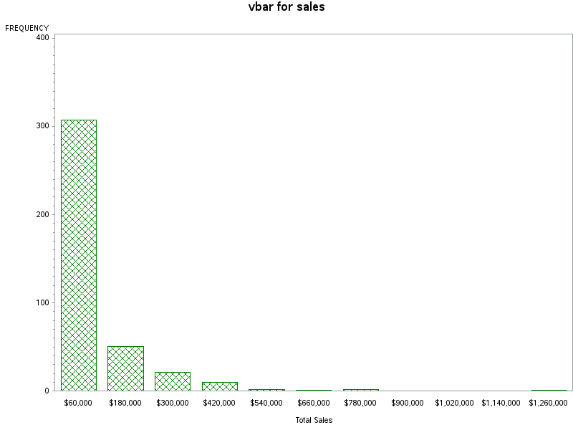

- title "hbar for type";
goptions reset=all
ftext='arial'
htext=1.0
ftitle='arial/bo' /*задаваме новото оформление и цвят червен */
htitle=1.5
colors=(red);
title "hbar for sales";
proc gchart data=sashelp.shoes;
hbar product; /* horizontal bar chart */ /*Чертаем хоризонтална хистограма за кaчествената променлива продукт */
run;
quit;

Резултатът е:

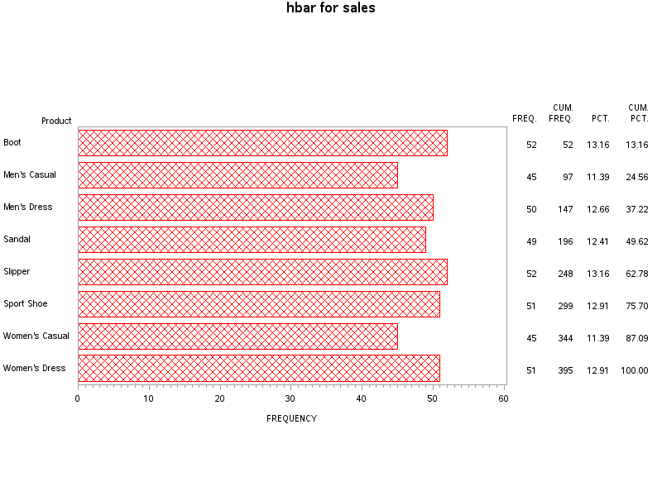
- goptions reset=all
ftext='arial'
htext=1.0
ftitle='arial/bo' /*Променяме цвета в синьо*/
htitle=1.5
colors=(blue);
title "pie for product";
proc gchart data=sashelp.shoes;
pie product; /*чертаем кръгова диаграма*/
run;
quit;

Резултатът е:

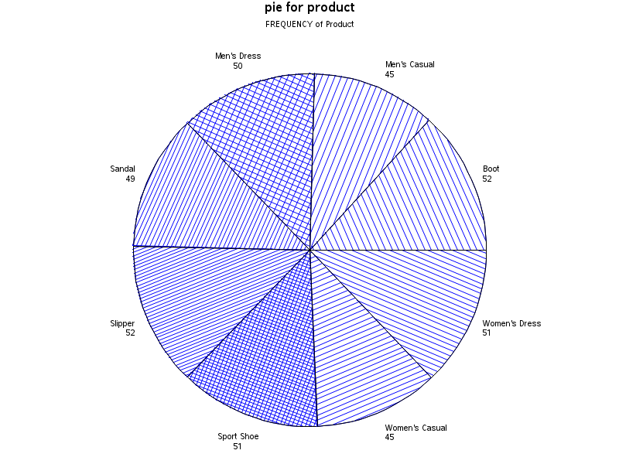

- goptions reset=all
ftext='arial'
htext=1.0
ftitle='arial/bo' /*Променяме цвета в синьо*/
htitle=1.5;
title "pie3D for product";
proc gchart data=sashelp.shoes;
pie3D product; /*чертаем кръгова 3D диаграма*/
run;
quit;

Резултатът е:
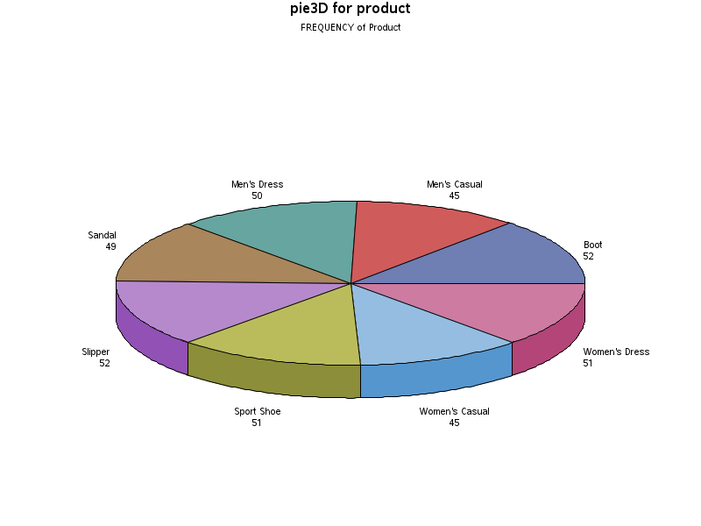

- proc gplot data=sashelp.shoes;
plot product * sales; /*чертаем графика за продукт и продажби*/
run;

Резултат:
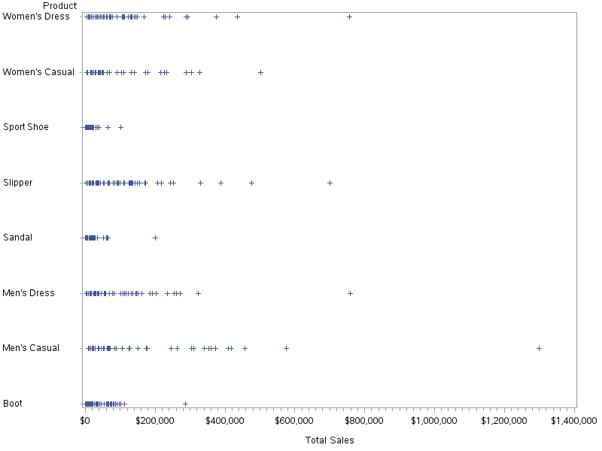

- symbol interpol=join;
proc gplot data=sashelp.shoes;
plot product * sales; /*чертаем графика за продукт и продажби като свързваме
данните с чертичка*/
run;

Резултат:
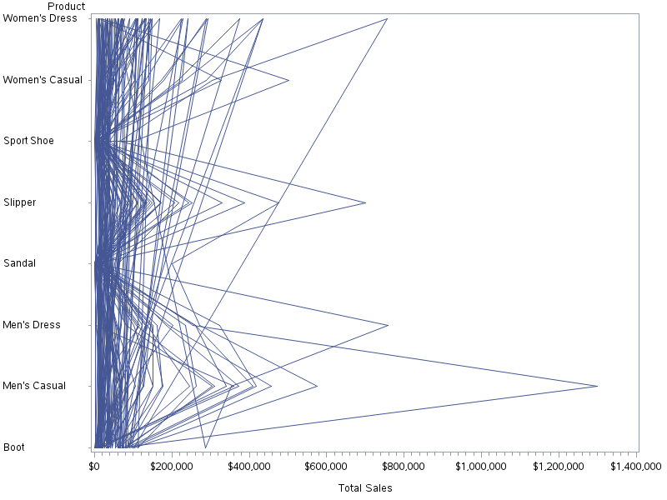

- symbol value=star interpol=join;
proc gplot data=sashelp.shoes;
plot product * sales; /*чертаем графика за продукт и продажби като свързваме данните с чертичка и отбелязваме данните с звездичка*/
run;

Резултат:
